1. Read the question and the student’s answer carefully.
2. Use the mark scheme to award the student a number of marks and annotate their answer with suggestions to improve.
Stretch: Rewrite the answer to show how it should be done!

Question:
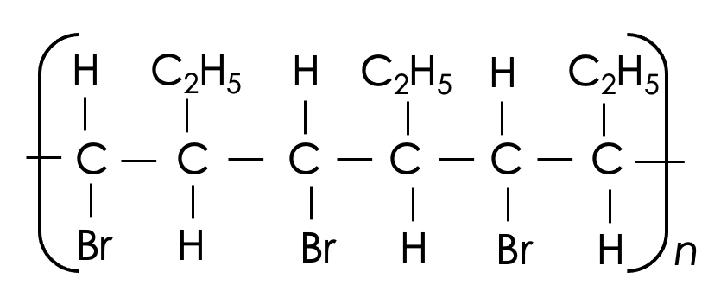
The displayed formula below shows part of a polymer chain.
Draw the displayed formula of the monomer used to make this chain. (2)

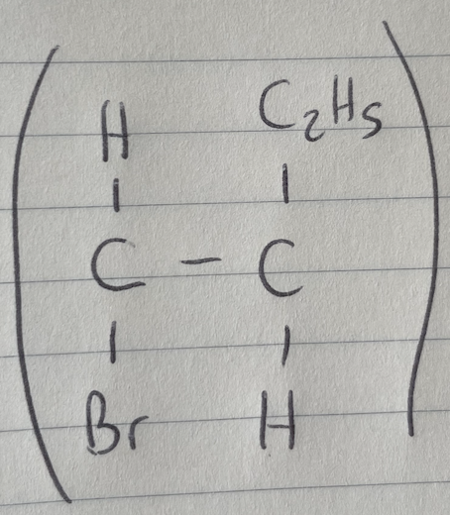
Student answer:

Marks awarded= _______
Mark scheme:

1 mark for correct atoms/groups
1 mark for correct bonds, including double bond
ignore brackets

